## Paper

* <https://arxiv.org/pdf/2112.10752.pdf>

## Code

* https://github.com/CompVis/latent-diffusion

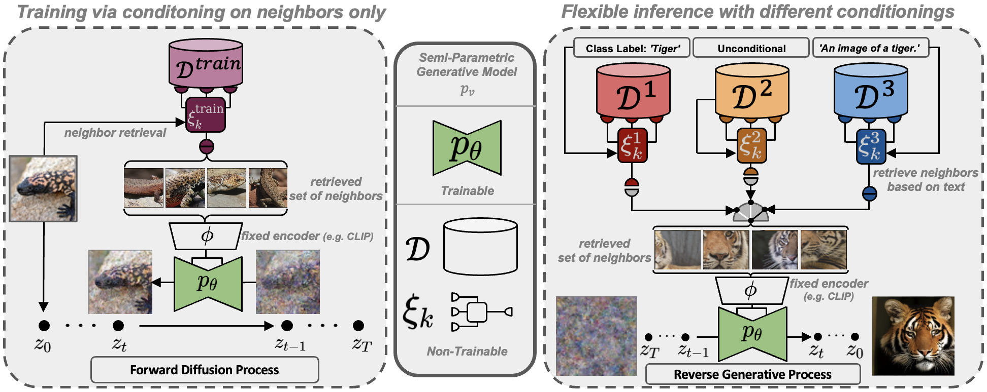

## Introduction to problem

* Autoregressive transformers
* GANs are data confined and have limited variability
  + Does not scale well
* Here comes diffusion models
  + Built from denoising autoencoders

## Diffusion model downsides

* Needs to increase accessibility and reduce resource consumption

## Deep dive into model

* The paper dives analyzes the latent space of DM to find improvements
* **Perceptual compression stage**
* Semantic compression

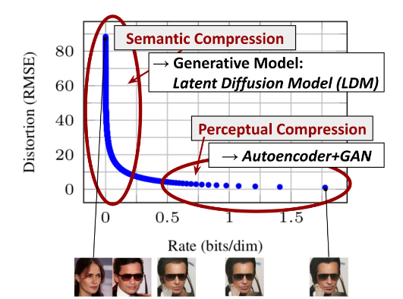

## Contributions

* Paper claims to scale better with higher dimensional data
* Claims to achieve better performance on multiple tasks (unconditional image synthesis, inpainting, stochastic super-resolution) while significantly lowering computational costs and decreasing inference costs.
  + Unconditional image synthesis - task of generating *images* with no condition in any context (like a prompt text or another *image*).
  + Inpainting - **conservation process where damaged, deteriorated, or missing parts of an artwork are filled in to present a complete image.**
  + Stochastic super resolution - for increasing resolution of an image
* Their approach does not require a delicate weighting of reconstruction and generative abilities. This ensures extremely faithful reconstructions and requires very little regularization of the latent space.
* We find that for densely conditioned tasks such as super-resolution, inpainting and semantic synthesis, our model can be applied in a convolutional fashion and render large, consistent images of ∼ 10242 px.
* They designed a general-purpose conditioning mechanism based on cross-attention, enabling multi-modal training
  + use it to train class-conditional, text-to-image and layout-to-image models.

## Related Work

* Generative models for image synthesis
  + Difficult to optimize
  + Likelihood based methods are better
* Diffusion probabilistic models (DM)
* Two stage image synthesis

## Method

* Introduces separation of compressive form from generative learning phase

### Perceptual Image Compression

* Based on previous work
* Autoencoder trained with perceptual loss and patch-based adversarial objective
* Has KL-reg
* Done during training
* First, we train
* an autoencoder which provides a lower-dimensional (and
* thereby efficient) representational space which is perceptu-
* ally equivalent to the data space.

### Semantic Image Compresision

* In latent space

### Latent Diffusion Models

### Conditioning Mechanisms

* augmenting their underlying UNet backbone with the cross-attention mechanis

## Experiments

## Discussions

* Is Unet pretrained?
  + Unsure yet
* Which part refers to the autoencoder
  + Its the initial pixel space
* Whats their loss for actual training
  + its only using 1 model
  + 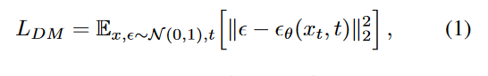
  + They only train the denoiser
  + Squared L2 norm
* What is T_theta
  + Apparently it is the output of the conditioning mechanisms
  + It is where you jointly train T_theta
  + unmasked transformer which processes a tokenized version of the input y
  + to infer a latent code which is mapped into the UNet via (multi-head) cross-attention (Sec. 3.3).
* What is time conditional unit ?
  + Seems to be a positional encoding

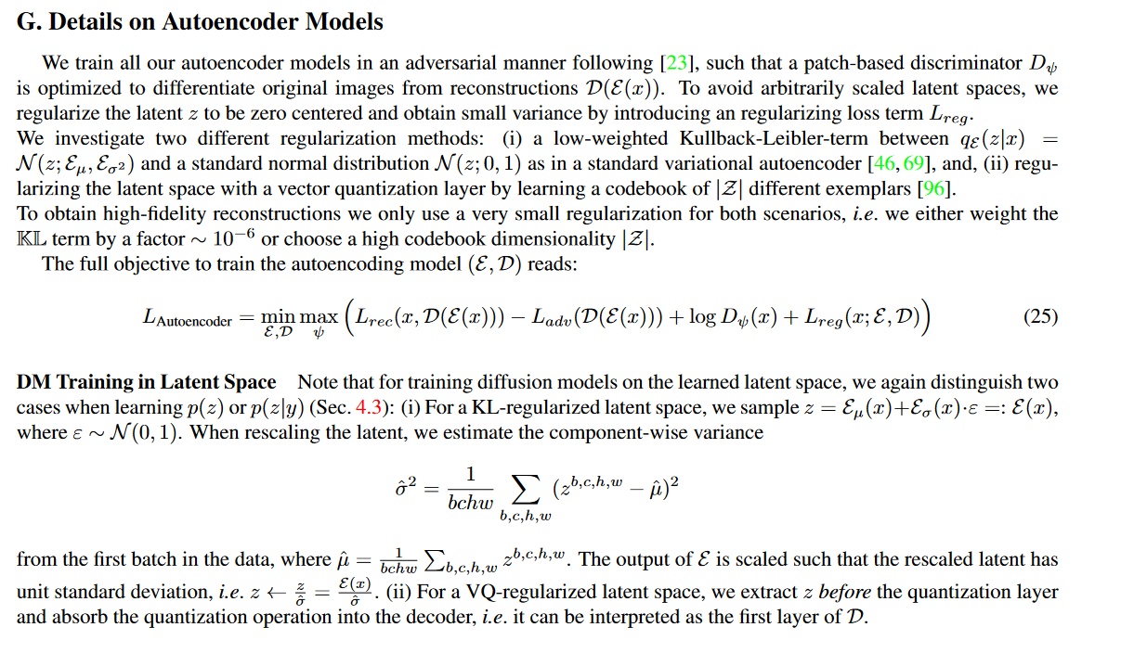

## Code

* <https://github.com/CompVis/latent-diffusion/tree/main/ldm/models>
* <https://github.com/CompVis/latent-diffusion/tree/main/ldm/models>

## Ddim and ddpm

* <https://github.com/CompVis/latent-diffusion/blob/main/ldm/models/diffusion/ddim.py> ]

They use this mainly

* <https://github.com/CompVis/latent-diffusion/blob/main/ldm/models/diffusion/ddim.py>

Why add positional encodings vs concat

* It seems concat makes more sense because you dont change the weights ? intuitively it makes sense
* It seems add is more computationally efficient
* <https://www.reddit.com/r/MachineLearning/comments/cttefo/d_positional_encoding_in_transformer/exs7d08/?context=3>